**Java Script**

1. **What is JavaScript?**

Ans: JavaScript (JS) is a scripting language, primarily used on the Web. It is used to enhance HTML pages and is commonly found embedded in HTML code JavaScript is the "engine" that makes things move on a page; by working with dynamic design elements.

1. **What is HTML?**

Ans: Hypertext Markup Language (HTML) is the standard markup language for creating web pages and web applications. With Cascading Style Sheets (CSS) and JavaScript, it forms a triad of cornerstone technologies for the World Wide Web

1. **How do you use JavaScript in HTML?**

Ans: JavaScript is most commonly used as a client side scripting language. This means that JavaScript code is written into an HTML page. When a user requests an HTML page with JavaScript in it, the script is sent to the browser and it's up to the browser to do something with it.

1. **How do you use JavaScript?**

Ans: We need not look very far to find a use for JavaScript and so opportunities abound for learning the language- rollovers, moving text, prompt windows and alert boxes are just a few of the action powered by JavaScript.

1. **What are the main features of JavaScript?**

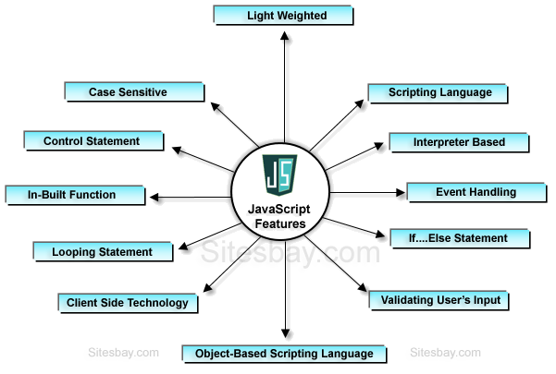Ans: **Features of JavaScript**

* JavaScript is an object-based scripting language.
* Giving the user more control over the browser.
* It Handling dates and time.
* It Detecting the user's browser and OS,
* It is light weighted.
* JavaScript is a scripting language and it is not java.
* JavaScript is interpreter based scripting language.

1. **What do you mean by interactivity?**

Ans: The concept of interactivity implies change in response to an action. Interactivity on a page, feature of the page change as the user moves, clicks or drags the mouse over the page.

1. **What is alert ( ) and how does it works?**

Ans: alert ( ) function is a built-in function in JavaScript. This function sends a message to the page.

1. **What is prompt ( ) and how does it works?**

Ans: prompt ( ) function is a built-in function in JavaScript. This function takes two arguments.

1. **Write a program to display alert ( ) for the viewer.**

Ans:

<script language="JavaScript">

alert("i told you it was simple!")

</script>

1. **Write a program to display firstName and lastName using Prompt ( ).**

Ans:

<script type="text/javascript">

var result;

var firstName;

var lastName;

firstName = prompt("Enter your name","");

lastName = prompt("Enter your Last", "");

result = firstName + " " + lastName;

document.write("Full Name" + result);

</script>